**Java Lab 8**

**Done By**: Rohit Karunakaran **Roll No:** 58

1.Write a Java program that implements a multi-threaded program which has three threads. First thread generates a random integer every 1 second. If the value is even, the second thread computes the square of the number and prints. If the value is odd the third thread will print the value of the cube of the number.

**Program Code:**

/*********************************************************

* A Multi-threaded Program which has 3 threads,

* Thread 1: prints a random number every 1 Second;

* Thread 2: If the number is even then print it's square

* Thread 3: If the number is odd then print the cube

* *******************************************************/

/*********************************************************

* Done By: Rohit Karunakaran

********************************************************/

class SquareThread implements Runnable

{

int i;

public Thread t;

public SquareThread(int a)

{

t = new Thread(this,"Square Thread");

i = a;

}

public void run()

{

int sq = i*i;

System.out.println("The square of the number "+i+" is "+sq);

}

}

class CubeThread implements Runnable

{

public Thread t;

int i;

public CubeThread(int a)

{

t = new Thread(this,"Cube Thread");

i = a;

}

public void run()

{

int qube = i*i*i;

System.out.println("The Cube of the number "+i+" is "+qube);

}

}

class RandomThread implements Runnable

{

int i;

//Random rn;

public Thread t;

public RandomThread()

{

//rn = new Random();

i = (int)Math.random()*100;

t = new Thread(this,"Random Number");

}

public void run()

{

for(int j=0;j<10;j++)

{

// i = rn.nextInt(); //Generates a random number from 0-99

i = (int)(Math.random()*100);

System.out.println("Random Number : "+i);

if(i%2==0)

{

//Square thread

new SquareThread(i).t.start();

//s.t.start();

}

else

{

//cubeThread

new CubeThread(i).t.start();

//c.t.start();

}

try

{

Thread.sleep(1000);

}

catch(InterruptedException e)

{

System.out.println("Interrupted");

}

}

}

}

public class RandomNumber

{

public static void main(String args[])

{

RandomThread r =new RandomThread();

r.t.start();

}

**Sample Input/Output**

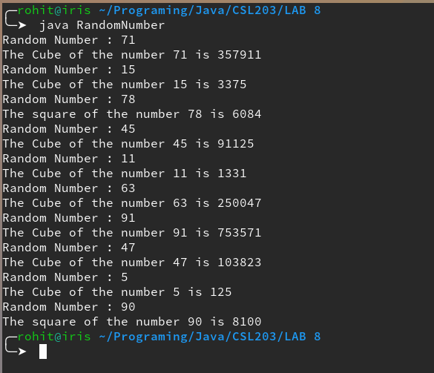}

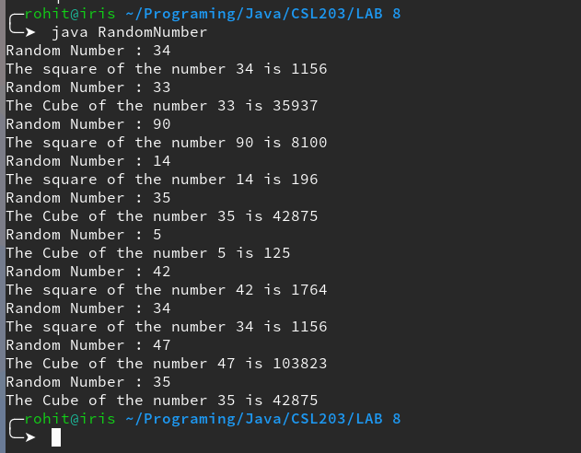

2.Write a Java program that shows thread synchronization.

**Program Code:**

/************************************************

* Java Program to Demonstrate Thread Synchronization

* Done By: Rohit Karunakaran

* **********************************************/

class Test

{

//synchronized void test(String msg) <--- Either this or look at line 35

void test(String msg)

{

System.out.print("["+msg);

try{

Thread.sleep(1000);

}

catch(InterruptedException e)

{

System.out.println("Interrupted");

}

System.out.println("]");

}

}

class ThreadsInSync implements Runnable

{

String msg;

Test target;

Thread t;

public ThreadsInSync(Test targ,String s)

{

target = targ;

msg = s;

t= new Thread(this);

}

public void run()

{

target.test(msg);

try{

Thread.sleep(2000);

}

catch(InterruptedException e)

{

System.out.println("Interrupted");

}

synchronized(target){

target.test(msg);

}

}

}

public class Synch

{

public static void main(String args[])

{

Test target = new Test();

ThreadsInSync ob1 = new ThreadsInSync(target,"Hello");

ThreadsInSync ob2 = new ThreadsInSync(target,"Synchronized");

ThreadsInSync ob3 = new ThreadsInSync(target,"Thread");

System.out.println("Without Sychronization");

ob1.t.start();

ob2.t.start();

ob3.t.start();

try{

Thread.sleep(2900);

System.out.println("With Sychronization");

}

catch(InterruptedException e)

{

System.out.println("Interrupted");

}

}

}

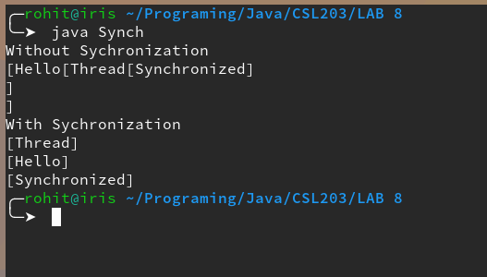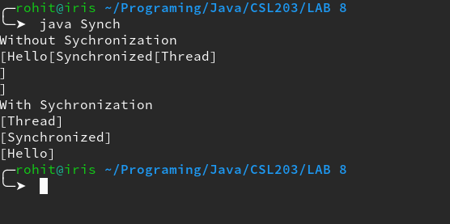**Sample Input/Output:**